**Report of Ex2_Simscape_DC_Motor_SPE**

**By: Punit Purohit(GD7198)**

**Submitted to: Dr. Jerry Ku**

**Correction:**

The model runs perfectly in 2016b version just one change is required:

The subsystem designed to reset the values fails because the name of the file is not proper. Right click on the Orig. Values block and click properties, in call back tab select OpenFcn in call back function list on left side and change the value of the content to ‘load SimElectronics_DC_Motor_SPE_Param_Start;’.

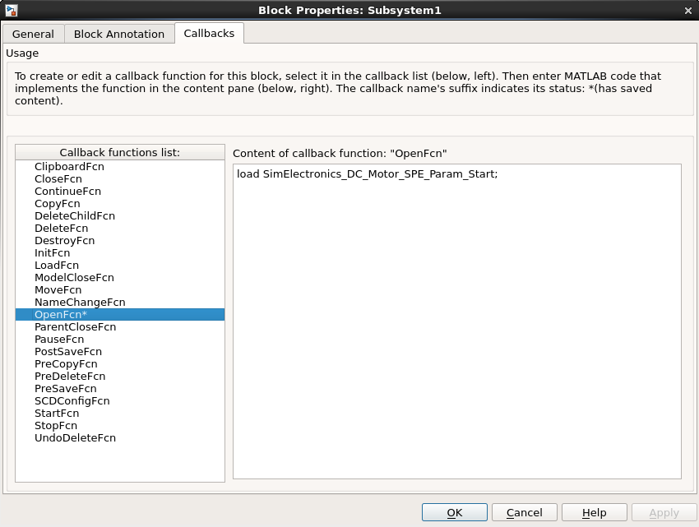

**Results and Discussion**.

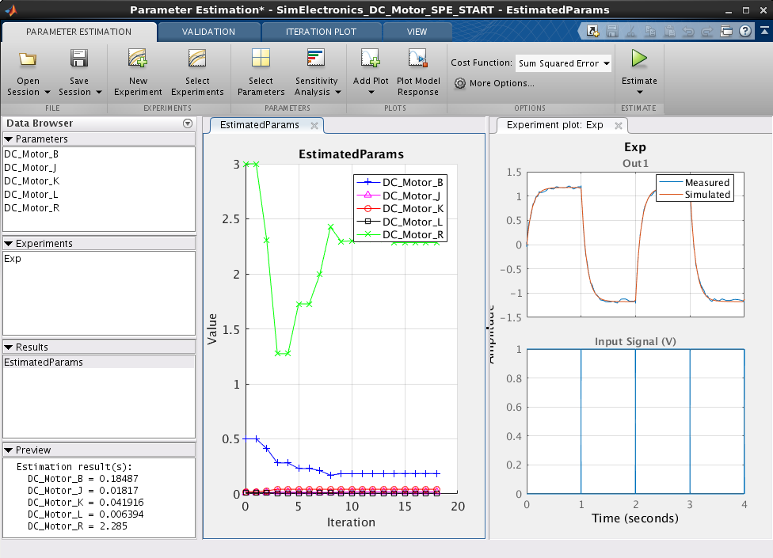The parameter estimation tool runs iterations and matches the output very closely to the measured data. Although the final values of the variables obtained is different from the tutorial the objective is achieved.

Figure Initial Results

It is obvious that there can be many combinations of the parameter values for the same output because of so much interdependence and the final parameter values obtained by the solver depends on the initial values and algorithm used and the level of accuracy required.

This Theory was put to test by trying some variations.

First, the initial values of all parameters were changed and parameter estimation was run again and the following results were obtained:

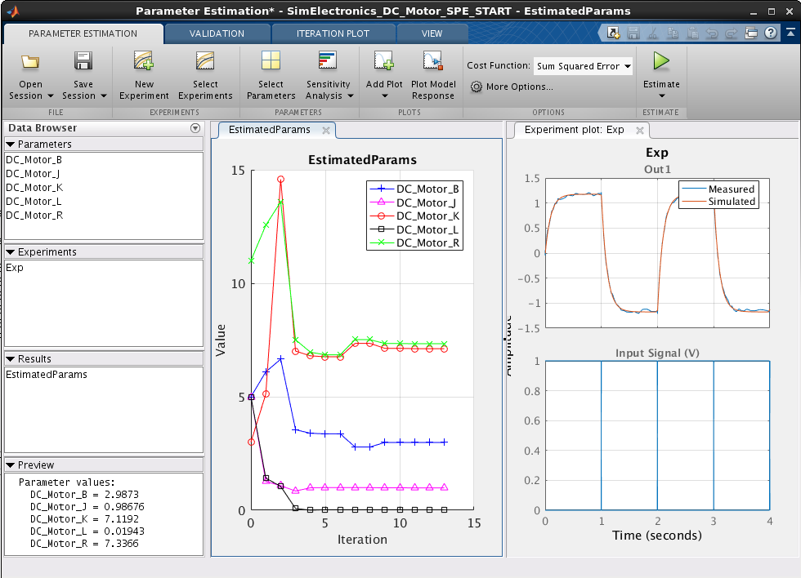

As it can be seen when initial values are changed the final parameter values also change with same output. Suppose we were designing a motor for a required output profile then this results shown that the same profile can be derived from different parameter value and hence there is further scope of optimization, like reduction in heat generated or power consumption etc.

Another scenario that I tested was, if the resistance of the battery in known say 5 ohms then it would be easier to find other values. By fixing the resistance value following results were obtained.

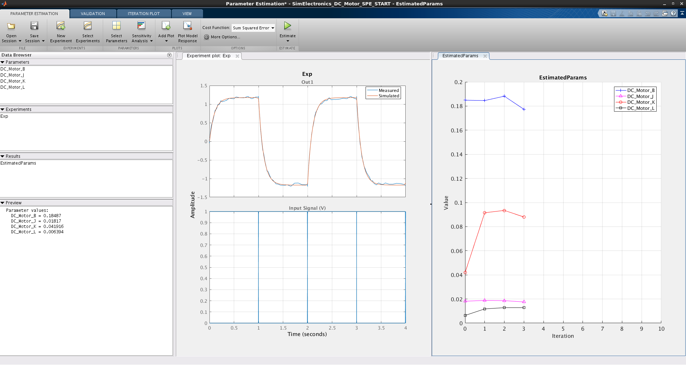

Result of another simulation for the fixed resistance and increased initial value of other parameters:

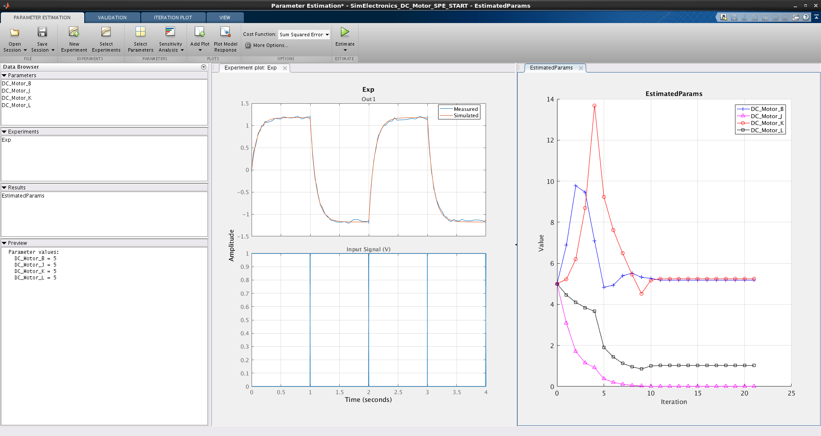

**Conclusion:**

MATLAB makes the job of parameter estimation easier and the output of simulation is very close to measured data. But these parameters are for this set of input and matches this experimental results. In different experiment these values may or may not hold true. I believe the obvious next step should be to validate these values with a different experiment to gain confidence on the parameter values obtained.